**HTML and CSS**

To get started with HTML and CSS, please see following videos.

1. <https://www.youtube.com/watch?v=OZeoiotzPFg>
2. <https://www.youtube.com/watch?v=yyqvXhu-HOc>

1. **HTML Task**
2. What is HTML? Give basic structure of the HTML page.
3. Difference between inline and block level element.
4. Create an HTML page “index.htm” with following content

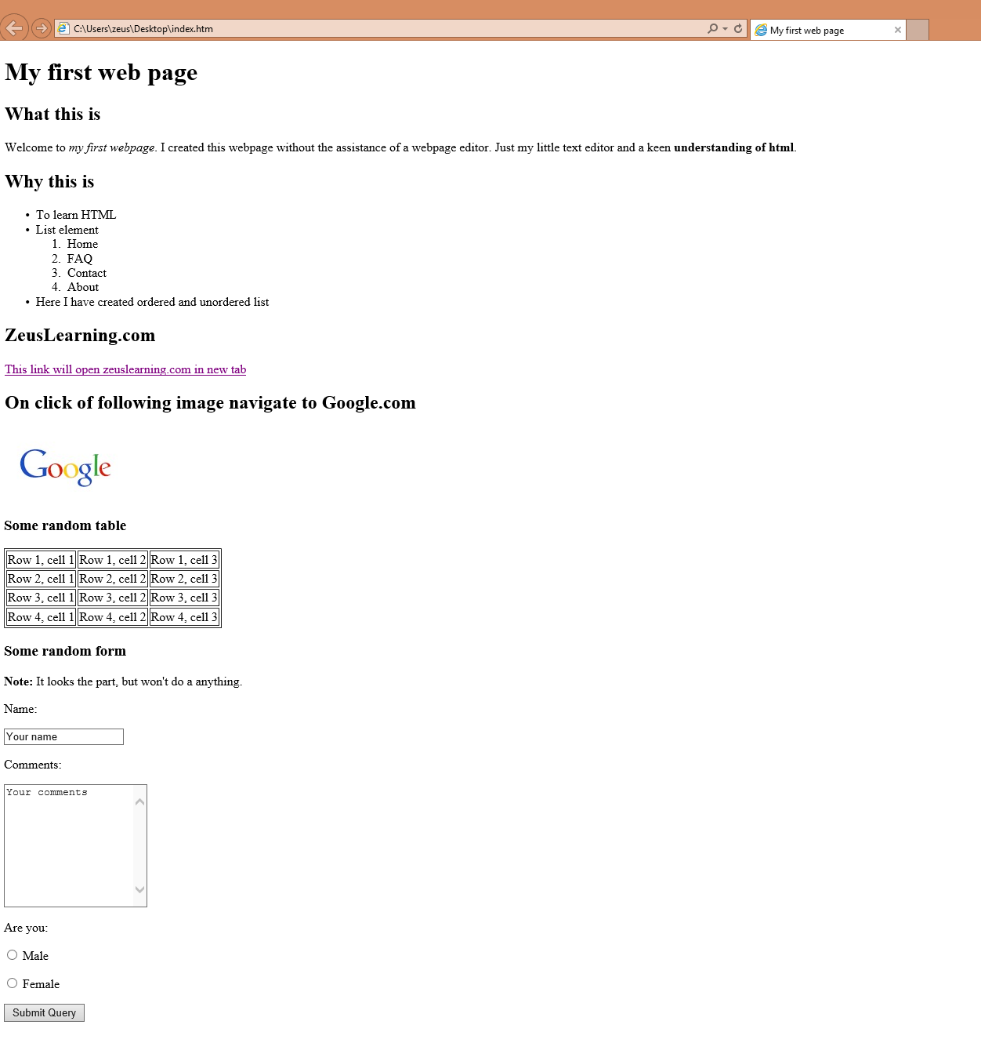

1. **CSS Task**
2. Explain the different ways in which CSS can be applied to HTML, what is the preferred way and why.
3. What are different CSS selectors, with example explain Element, Class and Id selectors.
4. With the help of a diagram explain CSS Box Model.
5. To HTML page create in the task 1.a, apply following CSS

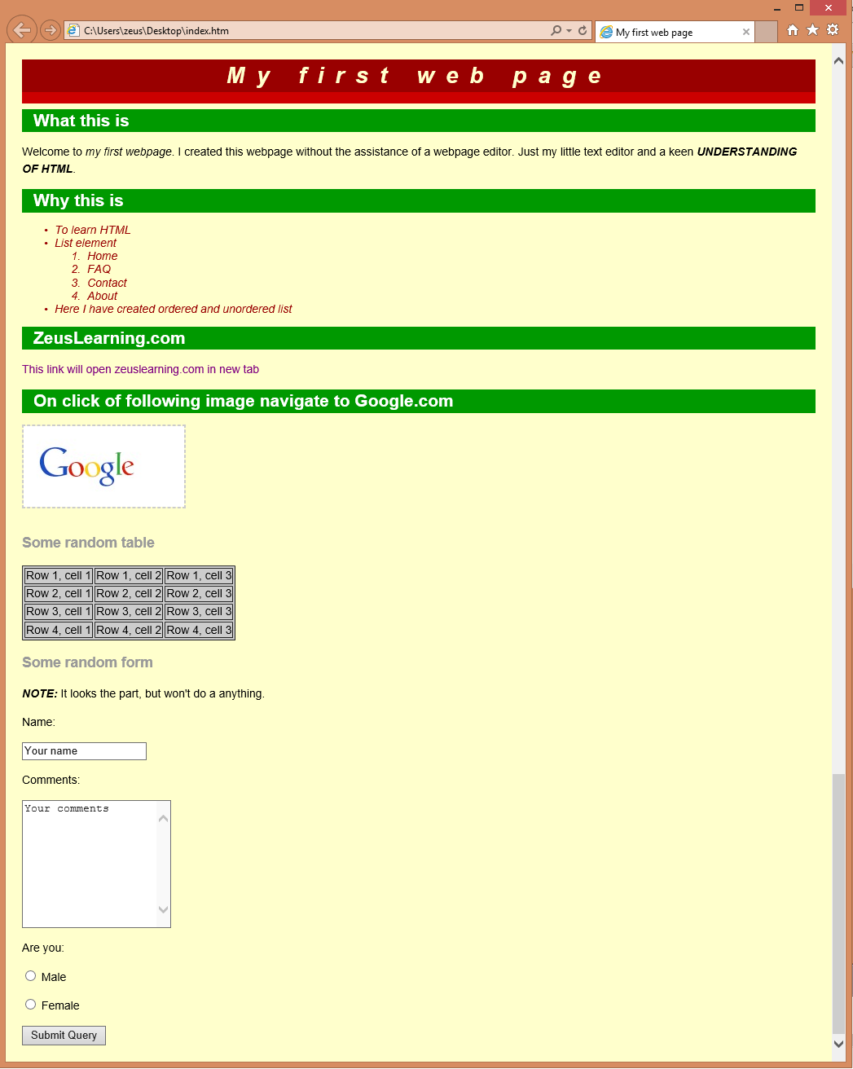

**JavaScript**

1. List down ways in which JavaScript command can be added to a webpage, what is the preferred way.
2. To the webpage created in the task 2.d , on click of “Submit” button call JavaScript function to validate:
3. Name and comments fields are not empty.
4. User has selected one entry from male/female radio button
5. In case user has not entered data for name and comment field or not selected anything from male/female radio button – show alert message “All fields are compulsory” and set focus to the first filed that is empty.